New testing has been performed for the time reversal portion of the self healing project. There were actually two separate tests that were carried out. One of the tests was to determine how quickly the amplitude of ringing due to natural frequency oscillations would diminish. The goal of the second set of tests was to perform focusing of energy at a “defect” transducer placed towards the middle of the rod. The focusing was done by using a time reversal method. Both of these tests are detailed more in our 2011 AIAA paper.



Figure Setup for the ringing tests

For the ringing tests, we looked at two different types of energy patterns and their characteristics in the steel rod. The first was a single data point 14V pulse that was sent through the steel rod using a PZT. The sending PZT and the PZT on the opposite end of the rod then read in data samples. Below are graphs of the single pulse tests.



Figure Signal read by the sending PZT after it sends the single data point 14V pulse



Figure Signal read by the PZT on the opposite end of the rod after the single data point 14V is sent

The second type of pulse that was used was a multi-toned pulse. This is the same pulse that was used for previous time reversal testing and is also being used in the current time reversal testing. The testing procedure is the same as what was done for the single data point 14V tests. Below are graphs of the pulse that was used and the signals read by each PZT.



Figure Multi-toned pulse used for both the ringing tests and the time reversal tests



Figure Signal read by the sending PZT after it sends the multi-toned pulse



Figure Signal read by the PZT on the opposite end of the rod after the multi-toned pulse is sent

With both tests, you can see that the amplitude of the pulse within the rod diminishes rather quickly. With our time reversal testing, we implement a 2.5 second wait time before we reverse our signals. The x-axis on the graphs is actually the number of samples taken. The samples are taken every 1.35 microseconds (~740.741 KHz). You can see in both cases that the ringing is gone within 2 milliseconds of the pulse being sent. This should not pose a problem for us.

As mentioned above, the other set of experiments for the self healing project that were performed were to extend our previous testing with time reversal. Previously, we had been able to “focus” energy on a PZT on either end of a steel rod by using a time reversal method. The current testing has moved forward by focusing energy at a “defect” transducer that is placed between two rods. This more accurately reflects focusing energy at a crack location within a system. With the previous testing, we were combining the energy from two pulses using time reversal. However, this energy propagated through the whole rod instead of occurring at a single location. With the current testing, we are causing the energy from the two pulses to combine at a single point; the “defect” PZT between the two rods.

The setup that was used is almost identical to one used for the ringing tests. The difference is that a second rod segment is added to one end of the system. A PZT that was once on the end is now sandwiched between the two rod segments and acts as a defect. A third PZT is placed on the open end of the second rod segment so that there are now PZTs on each end of the system to both send and receive signals. This testing was performed with two different second rod segments of two different lengths. One of the rod segments was the same length as the first which means the defect PZT was in the middle of the system. The other rod segment that we tested with was an arbitrary length that was shorter than the first rod segment. Testing with the two different lengths helps to reinforce the notion that we are able to use time reversal to focus energy at a crack with a random, unknown location.

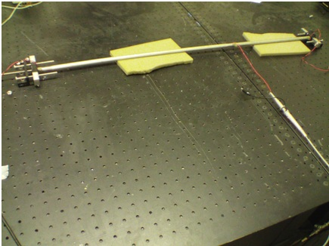

Figure 7 Setup used for the time reversal tests. Notice that two rod segments are now used with a PZT sandwiched between the two rods. This PZT acts like a defect in the fact that it will both reflect energy and let some pass through.

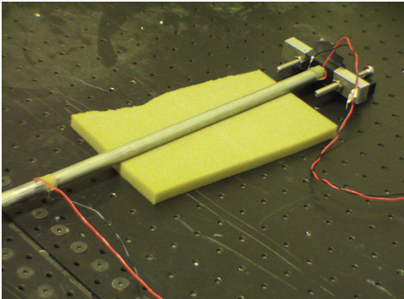

Figure Close up of the right hand side of the system which shows the defect PZT and the second rod segment which is shorter than the first segment.

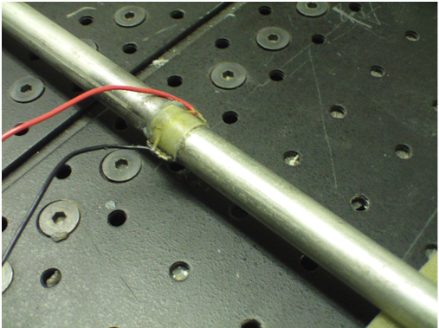

Figure Close up of the defect PZT

The software that was used for the recent testing is actually almost the exact same software that had been used for previous testing. Only very small modifications had to be made in order to get the program to work for the current tests. This is very encouraging as it also lends a hand in showing that both the time reversal algorithm and software are robust. The program sends a multi-toned pulse from one of the end PZTs. The signals are read by the end PZTs, and the response amplitude at the defect PZT is recorded. The captured signals are then filtered, rescaled, time reversed, and then played back. Again, the signals are read by each of the end PZTs and the amplitude of the response at the defect PZT during this time reversal phase is recorded. The response at the defect PZT during the initial phase is compared to the response during the time reversal phase to see if the amplitude increased and if focusing occurred.



Figure The signals read by the end PZTs during the initial phase of the algorithm. PZT0 sends the initial pulse.



Figure The filtered, rescaled, time reversed signals that are played back by their respective end PZTs



Figure Response at the defect PZT during the initial phase and during the time reversal phase. Notice that the amplitude of the signal read during the time reversal phase is greater than that read during the initial phase

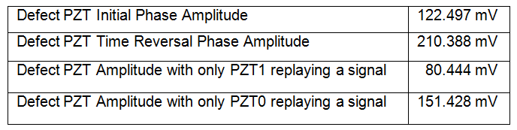

Figure Amplitudes achieved at the defect during testing

From the data above you can see that we are in fact focusing energy at the defect PZT. The amplitude that is recorded at the defect when both PZTs play back during the time reversal is almost the sum of the amplitudes recorded when only one of the PZTs plays back. This strongly suggests a combination of those waves when both PZTs playback. The results were the same for both the second rod of equal length to the first and the second rod of shorter length than the first. Our next step is to look at time reversal in multiple dimensions.

Another test setup for the time reversal that was visited was the notion of using water as the transimission medium for the acoustic energy. This testing was actually done prior to the testing that is covered above. The advantage that was thought to be had from this was that it would be easy to place a sensor at any location in the system to act as a defect and record the response at the location. A PVC pipe and fittings were used to make the setup. Transducers were installed on each end of the tube. Two separate types of transducers were tried; hoop mode transducers and flat disk transducers.

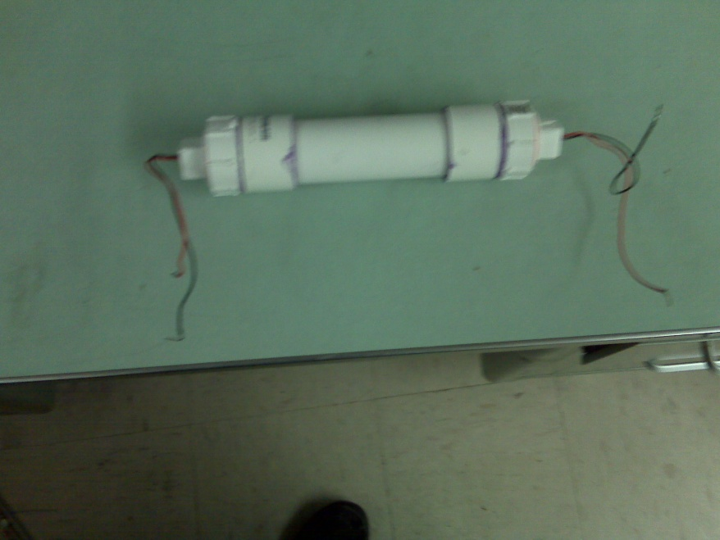

Figure Setup used for the water time reversal testing

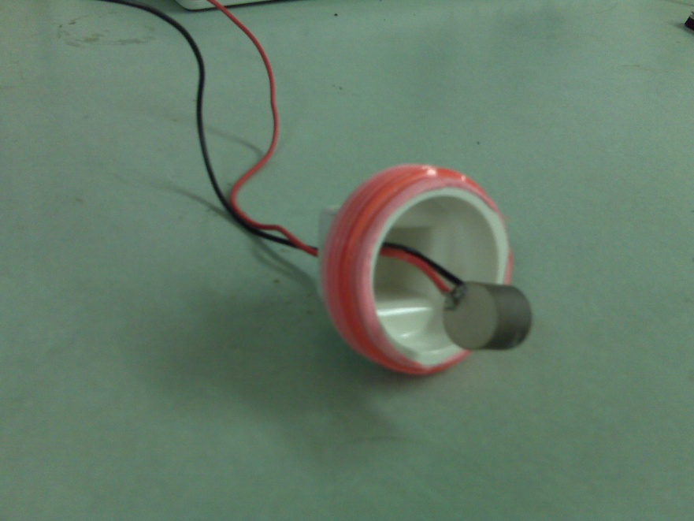

Figure Close up of one of the hoop mode transducers

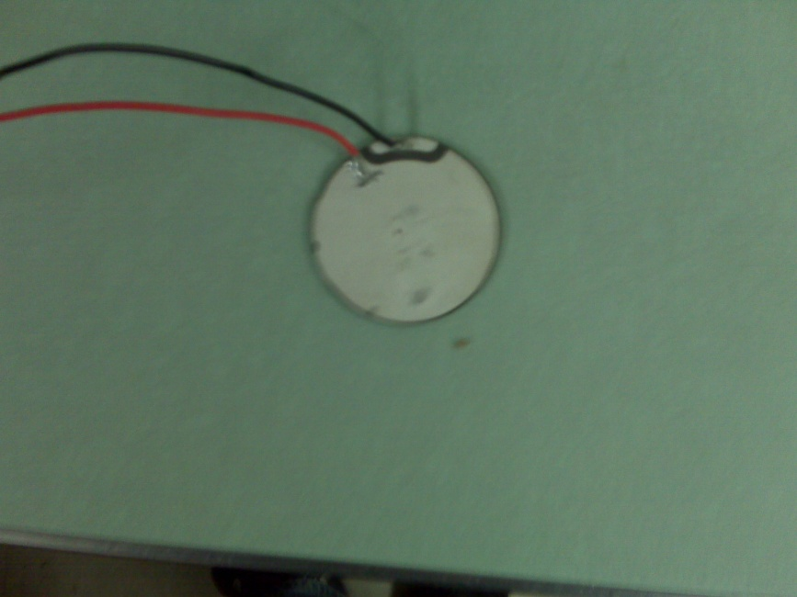

Figure Close up of one of the flat disk transducers

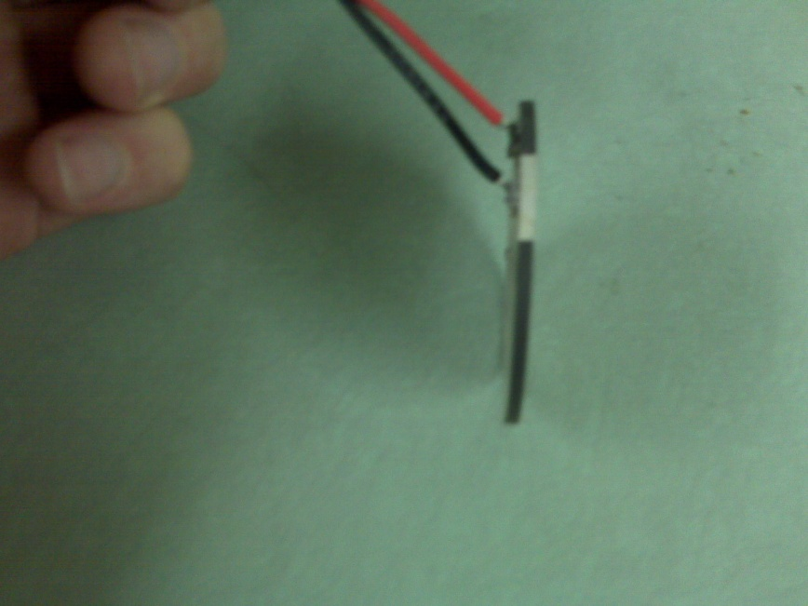

Figure Side shot of the flat disk transducer

One of the initial problems was purging the air from the system. One idea that was suggested was to fill and seal the tube while it was under water. This would work for ensuring no air would be in the tube. However, another problem that immediately followed is that water will actually travel through the wires coming out of the tube and leak out due to the pressure difference between the inside of the tube and its surroundings. The next idea was to just perform the tests while the tube was still submerged in water. A large rubbermaid tub was filled with distilled water and the tube was filled and sealed while submerged. We first performed tests using an oscilliscope and a AWG that was hooked up to our custom amplifier. We were able to get readings from a transducer while sending a continuous signal through the other transducer. When we tried to send a small pulse instead of a continuous signal, however, we were unable to get any readings. We are not sure of the exact explanation for this. We had decided to abandon this testing for the time being in favor of trying more ideas with the steel rods and PZTs.

I will now talk above the progress on the electrostatic deformable mirror project starting with the oldest to the newest. It was found that overflow errors were occurring in the FPGA program. As of right now, with an FPGA system if you are going to use numbers with decimal precision then you have to use fixed-point number representation. With fixed point representation, you have to seperately specify the number of bits that will be used to represent the integer portion of the number and the number of bits that will be used to represent the decimal portion of the number. This fixes the place of the decimal point and the range/precision to the left and right of it; hence the name “fixed-point.” This means that if a number requires more bits to represent it on one of side of the decimal point than are available to it, the system will **not** automatically adjust the decimal point to allow for accurate representation of the number. This is in contrast to the floating point decimal representation that most people are used to on computers. Floating point numbers will allow for the decimal place to be shifted in order to compensate for an increased demand in the number of bits used to represent a number (i.e., either an integer outside the range of the bits or a decimal that is too small to be represented by the given bits). A natural suggestion would be to give all numbers 32 bits of precision for their integer portion and 32 bits for their decimal portion. Unfortunately, this requires a large amount of space. Not only does it require space in storing the variables, it also requires space for the math operations to work on those variables. Space is something that is not abundant in an FPGA system. This means that stringent simulations must be run to get an operating range on all of the variables that are used in the program in order to specify a range of bits that accomodates the numbers while using the minimum amount of space. Not just the variables are looked at; the output of each math operation must also be analyzed. For each math operation, it is necessary to specifiy the bits used for the number that it outputs.

If at anytime during testing a number occurs which is outside of the range of representation of bits assigned to it then an overflow occurs. Sometimes it is very apparent when one occurs; other times it is not. What is needed is to periodically compare the results of real life testing with those of an equivalent computer simulation. After doing this, we found that we were in fact encountering an overflow error. Many heavy optimizations were made to the code used for the control system. These optimizations freed up a large amount of space on the FPGA card. This new space was able to be used to give the variables in the program a larger range and avoid overflow errors. The program was then rewritten to implement these new ranges for the variables and math operations. So far during testing we have not encountered any more overflow errors.

We have been looking into other ways to sense the displacement of the mirror other than the laser and quad cell. The laser and quad cell measurement relies on a specific scaling factor to translate the laser movement into gap position. This factor is not straight forward to find, as it also depends on other factors such as the position of the laser on the mirror and is subject to error if the position is not known exactly. This along with errors in measurement from the quad cell make it desirable to find a more accurate, robust method to determine the state of the mirror with respect to gap position and velocity at any given moment. An accurate measurement of these items is somewhat crucial to the proper performance of the closed control.

One idea that was tried was to sense the amount of current flowing through the mirror. We researched some ways to do this and decided to try out a current transducer that we found. This is a small circuit board that contains a Hall effect current transducer that is able to sense the current flowing through a wire without being intrusive. This board then outputs a voltage corresponding to the amount of current that is flowing. A nice feature about this is that you are able to wrap your wire through the transducer multiple times in order to increase the precision. We had planned to build a new observer function around this current sensing. Unfortunately, the amount of current that flows is so small that even with wrapping the wire more than 50 times around the transducer we were unable to get a reading. The current transducer was tested with another simple circuit and was verified to be working properly.

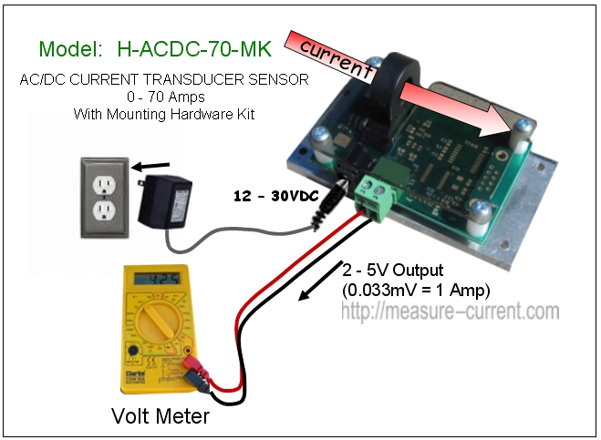

Figure Image of the current transducer taken from the company's website

A simple idea that was tried to measure the current involved the use of a large resistor. A 1 mega ohm resistor was placed in series with the mirror on the ground side of the setup. The voltage drop across the resistor was then measured and divided by the resistance to obtain the current (Ohm’s law). It was found that the current was in the nano to sub-nano amp range. It initially appears that there is not a large affect on the system when the resistor is in place. This is somewhat to be expected as the impedance of the resistor is far less than what is encountered in the air gap between the mirror and the actuators. We do, however, feel that this may not be a very accurate way to measure the current. We would like to search for other solutions and keep this one in mind as a possibility.

Another route we are looking at is sensing the capacitance of the mirror/actuators at any given moment. If the capacitance is known then it is almost trivial to determine the gap position of the mirror. A large amount of reading and research is being done to deterrmine a fast and accurate way to do this without changing the dynamics of the system. Most solutions discovered so far can deliver on one or even two of these properties, but not all three. We feel that finding a good way to do this will be very helpful to the project.

Numerous tests have been run to look at the actual critical voltages of the mirrors that we make in order to compare those to the caclulated voltages. A program was written that allows remote control of the voltage on our high voltage power supply. Any time the voltage is changed, the program will simultaneously take readings from the quad cell in order to record the behavior of the laser displacement. The quad cell is also hooked up to an oscilliscope so that the displacement can be monitored in real time in order to help visually detect snap down. During the testing the voltage of the power supply is increased one volt at a time and the mirror behavior is monitored. The voltage is increased until the mirror shows signs of snap down; such as hissing sounds and erratic readings from the quad cell. So far what we have seen is that the actual critical voltages are almost 3.5 times more than what we expect them to be by using the well known equation for critical voltage. We believe this could be due to the fact that the mirror membrane is not a perfect conducter and provides some resistance. It is also possible that the tension of the membrane is different from what we calculate it to be. We will need to work this factor into our program so that it can be compensated for.